Kafka–Sage Microservice Integration, Schemas, and GUID Mapping
Meeting Title and Date
Kafka Integration and Sage Microservice Workflow Discussion — Date not specified
Participants
  - Richard Brindley
  - Stephen (assumed from references)
  - Oliver (mentioned, not participating)
  - Tom (mentioned, not participating)
Agenda/Purpose
  - Clarify the end-to-end data flow between CymBuild, Kafka, Sage microservice, and Airflow.
  - Align on message topics, schemas, and responsibilities for invoices, payments, and clients.
  - Define storage and mapping strategy for GUIDs and Sage identifiers.
  - Identify next steps for API completion and Kafka integration.
Key Discussion Points
Overall Pipeline Understanding
  - Goal: Ensure full understanding of the Kafka-based pipeline for MDM Finance transactions.
  - CymBuild publishes invoice messages to “MDM invoices topic” in Kafka.
  - Sage microservice subscribes to relevant Kafka topics, translates messages, and interacts with Sage via Sage API.
  - Airflow periodically triggers the Sage microservice to fetch new payments from Sage.
  - Payments are published to an “MDM payments topic,” which CymBuild subscribes to and records if relevant (based on known cost centers and Urns).
Current vs Future Client Creation Flow
  - Current temporary workflow: Systems (e.g., Dynamics) produce a client-created message into Kafka, processed by Airflow, then distributed to other systems.
  - Future scope: Client creation may shift to a Power App (embedded/iframe approach), changing the source of truth and Kafka fan-out patterns.
  - Diagram noted as not fully accurate for current state; clarification provided on sensitive client handling and system visibility.
Topics, Schemas, and Message Formats
  - Kafka is schema-agnostic (“dumb”), but consumers require agreed schemas.
  - MDM Client schema: A referenced “MDM clients” object schema defines the expected client format (for Sage microservice consumption).
  - Invoice and payment schemas: Not yet defined; need collaboration to establish fields based on Sage requirements and existing practice (referenced “Sage Field Mapping” email).
Sage API Complexity and Mapping
  - Sage API involves ~32 endpoints, requiring extensive mapping from Kafka messages to API operations.
  - Payments should include allocation details in a single flow (no split flows).
  - Microservice serves as a translator between Kafka messages and Sage, and standardizes outbound payment messages for downstream systems.
  - Airflow may further convert standardized messages for applications outside direct control.
Identifiers, GUIDs, and Local Storage
  - Sage does not use GUIDs; the microservice will maintain a local Sage 200 database.
  - Local database will store:
  - Mappings between GUIDs (from source systems) and Sage primary keys/URNs (customers, invoices, payments).
  - External IDs and entity types (Sage’s classification).
  - Logs and links; sensitive data will be encrypted or excluded as appropriate.
  - When Sage creates payments, the microservice must generate GUIDs to propagate consistently across systems.
Usability and Tools
  - Whiteboard/diagram sharing issues (zoom, layout) acknowledged during the discussion.
  - Diagram corrections noted (placement and relationships among CymBuild, Kafka, Airflow, Sage microservice, and sensitive client handling).
Decisions Made
  - Payments topic will include allocation details in the same message flow.
  - Microservice will store GUID-to-Sage ID/URN mappings in a local Sage 200 database (links and logs only; secure handling).
  - CymBuild subscribes to the payments topic and records only payments relevant to known cost centers and Urns.
  - Proceed with current temporary client workflow via Kafka until future Power App solution is introduced.
  - Steven to provide a definitive JSON proposal for invoice/payment messages; Richard to merge with system needs to produce final schemas.
Action Items
  - Steven to provide definitive JSON for invoice and payment message schemas, including required fields and allocation details (Due: not specified).
  - Richard to draft/confirm the final invoice and payment schemas after reviewing Steven’s JSON and Sage expectations (Due: not specified).
  - Steven to complete Sage API endpoints (covering ~32 operations) and then proceed with Kafka integration mapping (Due: not specified).
  - Steven to schedule a quick review with Richard of the local Sage 200 database structures (links, GUID mappings, logs) once tidied (Due: not specified).
  - Richard to validate the current-state diagram and adjust for temporary client workflow and sensitive client handling (Due: not specified).
Next Steps/Follow-up
  - Finalize and agree on JSON schemas for invoices and payments.
  - Complete API endpoint implementation and verify end-to-end mapping from Kafka messages to Sage operations.
  - Establish and test the GUID-to-Sage ID mapping strategy within the local Sage 200 database.
  - Validate topic subscriptions and publication flow:
  - CymBuild → Kafka (invoices)
  - Sage microservice → Sage API (invoices)
  - Airflow → Sage microservice (payment fetch trigger)
  - Sage microservice → Kafka (payments with allocations)
  - CymBuild → consumes payments (filter by cost center relevance)
  - Revisit client creation workflow and diagram once the Power App approach and future scope are confirmed.
Invoice & Payments:

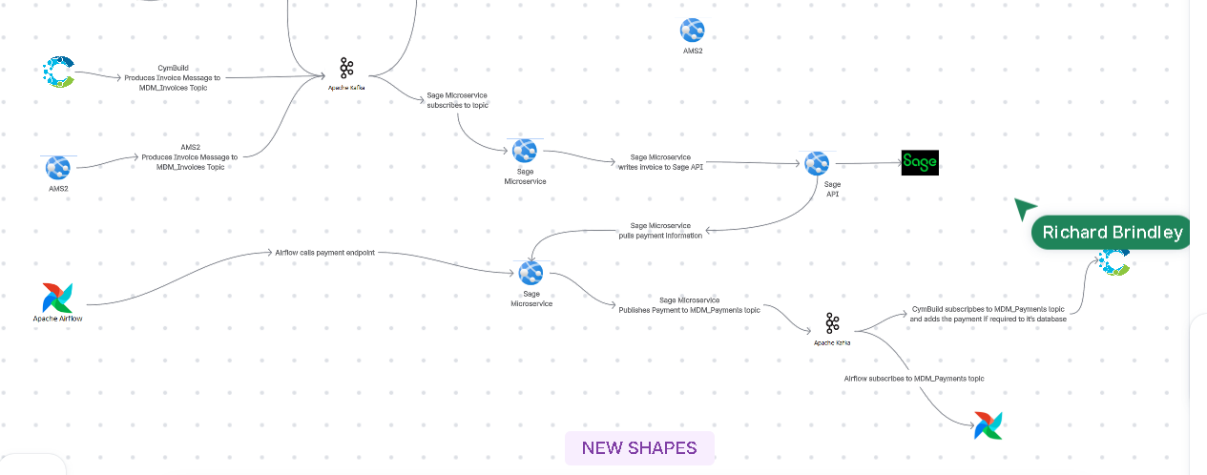

Customers:
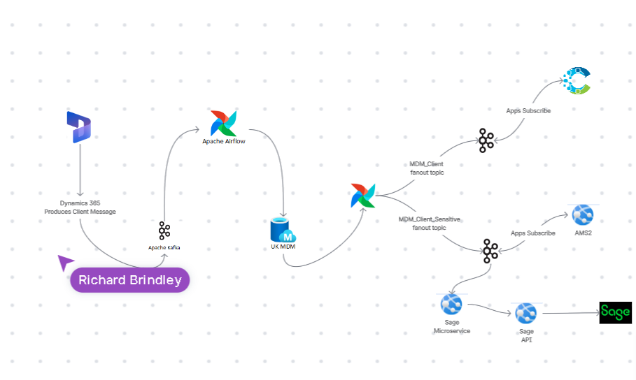

MDM Clients

MDM Object Schema (Kafka)

{
guid: uuid
name: str
code: str
parent_account: str
tax_reference: str
registration_no: str
duns_code: str
website: str
email: str
phone: str
relationship_manager: str
sector: str
sub-sector: str
classification: str
business_unit_assignment:
[
{
business_unit_code: str
}
]
addresses:
[
{
guid: uuid
is_main_address: bool
address_line_1: str
address_line_2: str
address_line_3: str
address_line_4: str
city: str
county: str
country: str
postcode: str
}
]
contacts:
[
{
guid: uuid
name: str
salutation: str
forename: str
middlename: st
surname: str
phone: str
mobile: str
email: str
job_title: str
}
]
}

